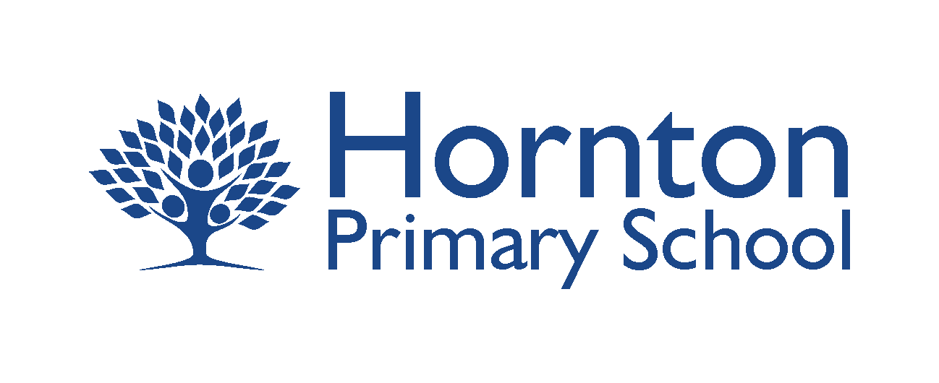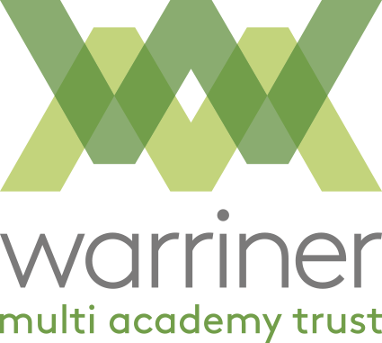

Curriculum Policy

Our Curriculum Vision
To create a school where we have a truly challenging, inspiring and relevant curriculum, one which is built upon the foundations of reading, writing and arithmetic.
A curriculum that is shaped by our moral purpose and develops the key skills of confidence, innovation and resilience. A curriculum which allows our children access to a broad and extensive range of key life experiences and opportunities so we continue to develop the leaders of the future.
Definition of our Curriculum
Our curriculum is the framework we have developed for setting out the aims of our programme of education, including the knowledge and understanding to be gained at each of the four phases of our school. We have translated that framework into a structure and narrative that is right for our context, our school and our children. We have a developed a set of assessment principles for evaluating what knowledge and understanding our children have gained against the expectations we set them.
Intent
At Hornton Primary School we will ensure that your children are happy, inspired and challenged so that they can make progress across the curriculum and achieve the highest standards possible. Your children will be taught by teachers with the highest expectations of them as learners; who plan and deliver a curriculum that is interesting, relevant and extends your children’s understanding of the subjects they are taught so they know more, remember more and can do more.
As your children progress through the school they will develop the highest expectations of themselves in terms of their learning and behaviour; they will be encouraged to be independent young people who can also work cooperatively alongside others. They will develop support skills and nurturing skills towards their peers and younger pupils and also organisational and administrative skills to support their learning.
The high quality teaching of reading, writing and mathematics are at the heart of our curriculum and are fundamental to the success of our school. To that end, as a school, we have agreed a set of reading, writing and mathematics targets for each pupil which builds on prior learning and challenges all children to become ‘masters’ of their subjects. These targets are indicative of our drive to achieve the highest possible standards and give all children, no matter their starting point or circumstance, the very best start in life.
As part of this Statement of Intent we have outlined below examples of how our school will enrich the curriculum in order to give all pupils the opportunity to excel and to ensure that they are inspired by their learning and motivated to learn more.
During the seven years at Hornton Primary School each child can expect to experience the following (this list of curriculum enrichment activities is indicative and subject to change over time):
- Regular opportunities to share their achievements in celebration assemblies and other whole school events
- Regular opportunities to contribute towards their learning and be involved in decision-making that effects the whole school through such things as the school council
- Opportunities to represent the school through sporting events and musical/classical dramatic performances
- A wide range of clubs and extra-curricular activities both after school and during lunchtimes
- The opportunity to play a variety of musical instruments
- Opportunities to work with the local community during events such as the Hornton May Day celebrations
- The opportunity to camp out under the stars and complete a night time nature walk
- The opportunity to observe the lifecycle of animals such as frog and caterpillars and then release them into the wild
- The opportunity to undertake cycling proficiency training
- Opportunities to perform in plays and other dramatic and musical performances and the support for those who find that challenging
- On-going opportunities to learn through practical, hands-on, investigative activities - growing fruit and vegetables, cooking etc
- The opportunity to ride a canal boat, visit a castle and trek through a rainforest
- Visit a zoo to study the natural world and impact humans are having on it
- The chance to research their own family tree and visit London on the train
- The opportunity to watch a sports fixture in an international stadium such as Wembley Stadium or Lords Cricket Ground
Visits and Visitors
During the seven years at Hornton Primary School each child can expect to experience the following visits and visitors to the school (this list is indicative and subject to change over time):
- A week long residential visit in Year 5 and 6
- A shorter overnight camping trip in Year 3 and 4
- Visits that are linked to topics and ongoing learning such as a trip to The Living Rainforest, Warwick Castle, The Natural History Museum and The Sea Life center in London, The Pitt Rivers Museum, The Steam Museum, Junior Citizen workshop, Oxford, a local farm to experience lambing and meet some animals
- The opportunity to play in local sports tournaments across the year at various locations across North Oxfordshire
- A visit from an author or poet
- The opportunity to be a mascot at the Kassam Stadium during an Oxford United match day
- Opportunities to perform classical drama in a local theatre
- A visit from a Viking

Implementation
At Hornton Primary School our curriculum comprises all the learning and other experiences that we plan to meet the needs and interests of our pupils. It is constantly evolving to develop the skills needed for children to become successful learners, help prepare them for life in modern Britain and empower them to achieve success in the future.
Our curriculum is planned in themes on a two-yearly rolling programme within each phase – Early Years, KS1, Years 3 & 4 and Years 5 & 6. Topics are chosen to capture the interests and imaginations of our children. Themes include but are not limited to; The Shang Dynasty, The Lady of the Lamp, Arctic Adventures, Natural Disasters, The Roman Empire, The Vikings, World War 2, Earth and Space, The Great Rainforests.
You can view our two year programme here
Skills-based learning is developed by linking subjects such as history, geography, art, design technology and music to the topic being studied. This allows children to make purposeful links in their learning. We also use every opportunity to make further links through reading, writing, maths, science and computing where relevant. PE and RE are often taught as discreet subjects to allow coverage of the main objectives and age appropriate skill development.

Impact
The school’s curriculum promotes and sustains a thirst for knowledge, understanding, development of new skills and a love of learning. It covers a wide range of subjects and provides opportunities for academic, technical, creative and sporting excellence. It has a very positive impact on all pupils’ behaviour and safety, and contributes very well to pupils’ academic achievement, their physical well-being, and their spiritual, moral, social and cultural development. In short our curriculum will enable children to know more, remember more and be able to do more.
We believe that assessment is at the heart of children’s learning and our teaching. This helps us build up a picture of a child's progress and achievement and also to help us and the children identify their next steps in learning.
Our principles for assessment are:
- learning is the main activity, we believe that assessment supports future learning
- assessment will take a range of forms including self and peer assessment as well as assessment by staff
- learners need to be actively involved in the assessment of their work
- learners should be confident and effective at self and peer assessment, being able to identify what they have done well and what they need to do next to improve
- learners must be clear about their learning, what success in their learning will look like and what is expected of them
- teachers professional judgement, based on their complete knowledge of the children, will be an important part of assessment
- “how often” as well as “how well” based on breadth, challenge and application will be fundamental to assessment
- progression in learning requires moderation through dialogue with teachers and other professionals to develop a shared understanding of standards
- high quality feedback has been proven to be the most influential factor in taking children’s learning forward, therefore, it is essential for learners to have time to reflect on their learning and know what to do to improve
- feedback will inspire greater effort and a belief that, through hard work and practice, more can be achieved
- assessment draws on a range of evidence that will provide a complete picture of a child’s achievement but will also be manageable and proportionate
- our assessment system will provide information to parents about how their child is performing and what their child’s next steps in learning are
- our assessment system also includes summative, age standardised assessments where we assign a mark to children’s’ learning at a particular point in time for example, reading ages or end of year assessments
Once our assessment information shows children have grasped a concept or demonstrated they have learnt a new skill or remembered new knowledge, they are taught to become ‘masters’ of that subject by studying it in greater depth. To this end, we will not push children onto content meant for older year groups but will instead challenge them to demonstrate their new found skills, knowledge and understanding through a variety of ways. These include, but are not limited to;
- teaching and supporting other children who have yet to grasp the concept or skill
- showing their understanding by representing their understanding in different ways for example showing an understanding of adding fractions by using concrete objects and resources instead of simply writing the sum
- becoming the ‘class teacher’ and leading discussions based on a topic or concept
- supporting teacher assessment by completing peer assessment
If our day to day assessment information shows a student has not grasped a concept, then a series of teacher or teaching assistant led interventions are implemented to support the student to ‘keep up not catch up’. Where necessary we will seek external support in order to help students overcome barriers to their learning. These interventions include but are not limited to:
- Daily reading interventions
- Daily handwriting interventions
- Daily mathematic interventions
- Weekly sentence level intervention to support development of writing
- Daily phonics interventions
- Play therapy
- Educational Psychological assessment
- Speech and Language support

Reviewed: February 2021 By: Karen Locke

Next Review: February 2023

Approved by the Full Governing Body on 18th March 2021

