Curriculum Outlines for Term 6
EYFS and Peach Tree Mrs Hart
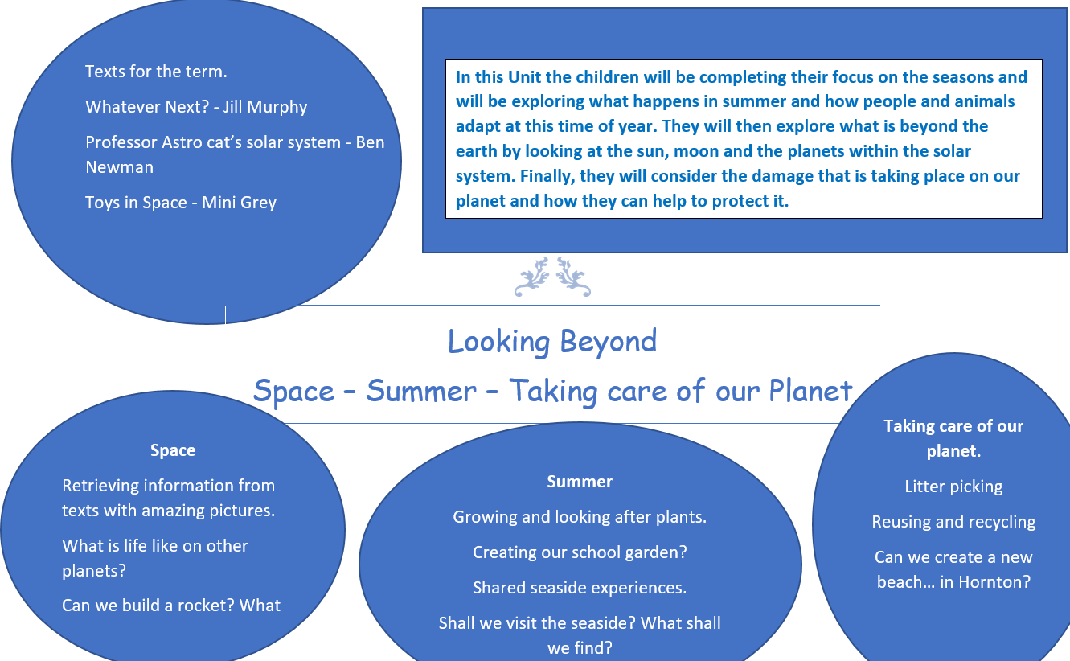
Oak Class Year 1 and 2 Miss Goddard
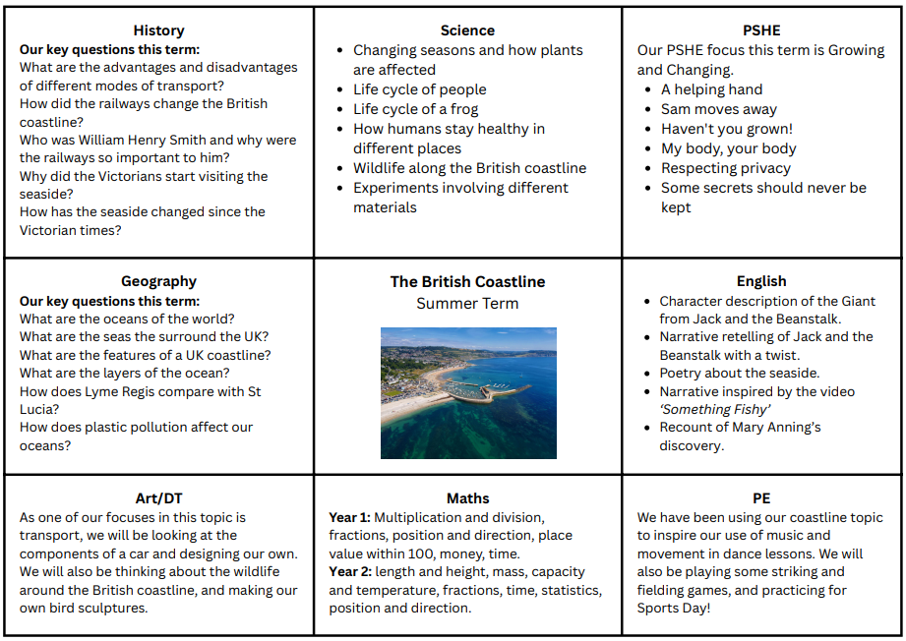
Willow Class Year 3 and 4 Mrs Tyrrell
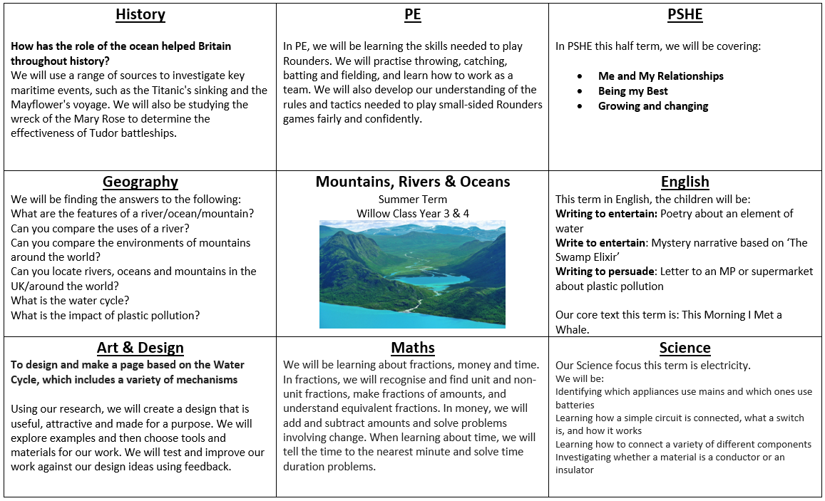
Rowan Class Year 5 and 6 Mr Runcorn
