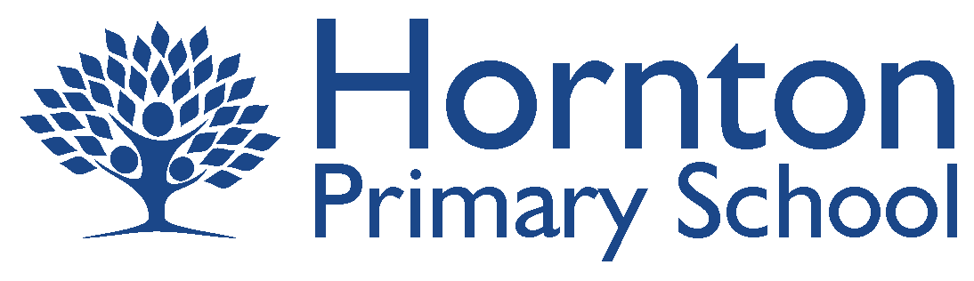

Updated January 2021
Updated October 2021

Post Covid-19 remote learning plan, following partial or full school closure.

Should we be advised to implement a reduction in attendance, we at Hornton Primary School want aim to be prepared.

Please be mindful, that provision will be subject to the ever changing situation that COVID-19 is placing upon us all. Whatever the circumstances, the staff at Hornton Primary School will work together to provide the highest quality teaching and learning as possible.

We will:
In preperation | Responsibility
- Provide all children with essential resources needed for home learning  - Support children and families having difficulty accessing appropriate IT equipment | KL  KL  KL
Daily
- Conduct a daily class meeting point via Microsft Teams  - Provide planned and sequenced lessons in English, Maths and the wider curriculum, set by the class teachers  - Follow up on the completed work to inform next steps in teaching  - Provide meaningful and relevant feedback to children, to support children’s progress | Class Teachers
Ongoing
- Provide feedback and support to parents and carers via email, phone calls and virtual meetings, during working hours  - Provide virtual / recorded lessons from other Trust schools if there are local lockdowns or local staff shortages due to illness  - Continue to offer SEN Support inline with SEN Support plans  - Keep to our calender of SEN Support Review meetings on Microsoft Teams  - Deliver printed resources to pupils who are unable to print  - Continue our commitment to safeguarding all children, in line with ‘Safeguarding and remote education during coronavirus  (COVID-19) (March 21)’, by:  - Providing clear communication routes for children, staff parents and carers, for reporting concerns  - Maintaining regular contact with children, parents and carers, following up on any non-engagement  - Working with other agencies to signpost/provide support where needed  - Teaching children about online safety  - Encouraging parents and carers to set age-appropriate parental controls on digital devices and use internet filters to block malicious websites.  - Encouraging parents to be in earshot of children using digital devices  - Only using communication channels approved by senior leaders  - Using school email accounts, not personal accounts  - Using school devices over personal devices wherever possible  - Recording lessons in school wherever possible, ensuring the visual and audible surroundings are appropriate at all times  - Providing chaperoned one to one sessions to students where appropriate  - We will continue to work to protect the personal data of children, teachers, parents and carers, in line with ‘Data Protection Act’ (2019)’, by:  - Using school email accounts, not personal accounts  - Using school devices over personal devices wherever possible  - Being careful not to share contact details when emailing multiple people  - Not to share usernames and other personal data for access to online resources  - We will continue with our commitment to promoting and maintaining the good mental health of children, teachers, parents and carers, by:  - Provide masterclasses and teaching plans for parents, if needed, to help support their children’s learning  - Provide feedback and support to parents and carers via email, phone calls and virtual meetings  - Sharing useful and relevant resources and activities  - Helping parents, carers and pupils to make a weekly plan or structure to include time for education, playing and relaxing, if needed  - Working with other agencies to signpost/provide support where needed  - Maintaining the appropriate working hours of teachers 9am to 5pm | Children and parents  Class Teachers  KL  KL  Staff  All stakeholders

If children are well but unable to come in to school, learning, parallel to that being completed in school, will be set to complete at home.

